Introduction to Graph database(NOSQL)

Week #2

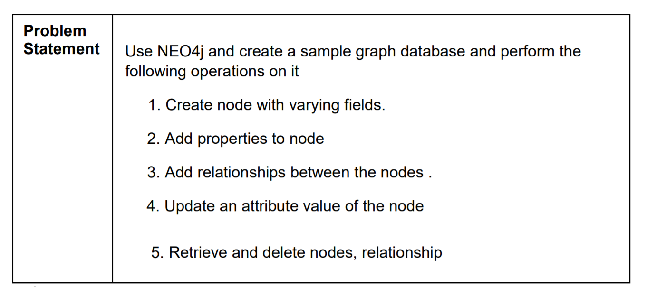

sudo neo4j start

available at http://localhost:7474/

//clear all records

MATCH (n) DETACH DELETE n

**1.Create node and relationships**

***I.*** *Create a single node :*

Syntax: create (n) // create a single node without label

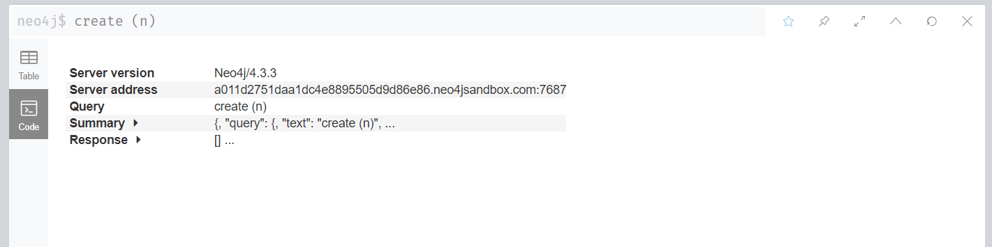

2. *Create multiple nodes*

Syntax: create(n),(m)

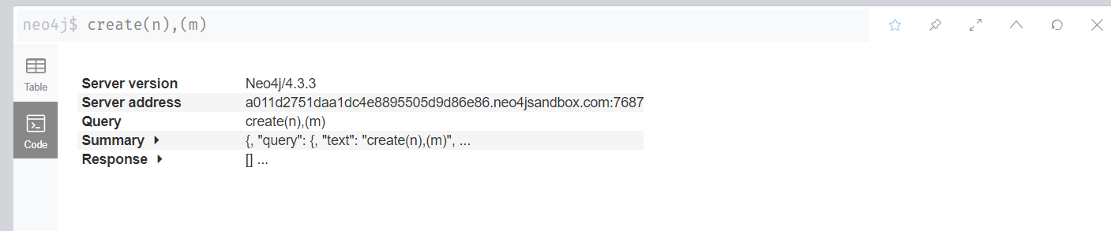

3. *Create a node with a label*

Syntax: create(n:lable name)

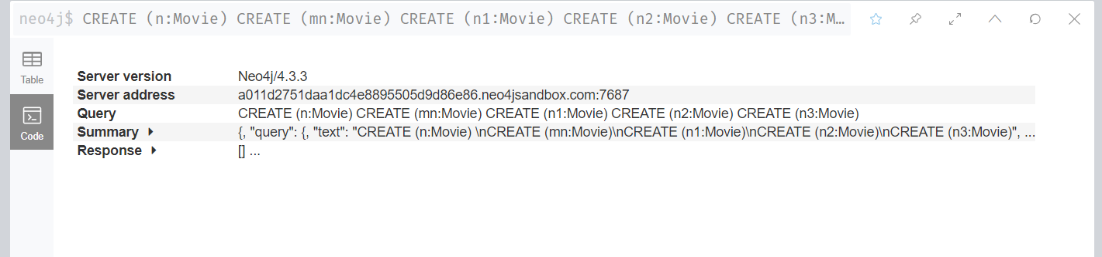

*4. Create a node with multiple labels*

Syntax:CREATE (n:Label1:Label2)

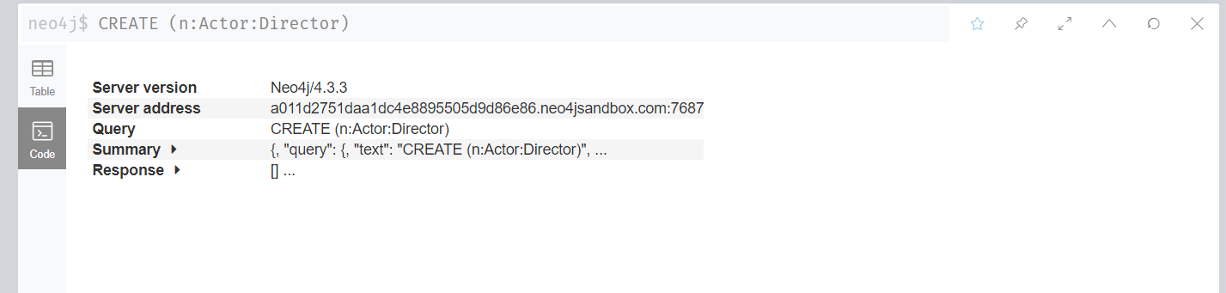

5. *Create node and add labels and properties*

Syntax: Create(n:lablename {properties and values});

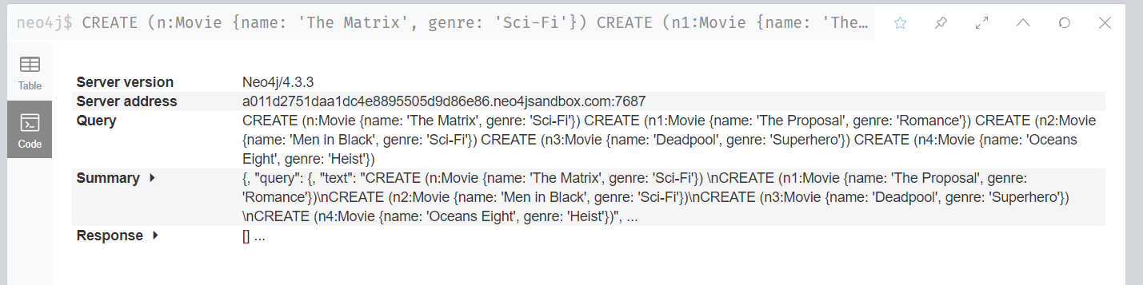

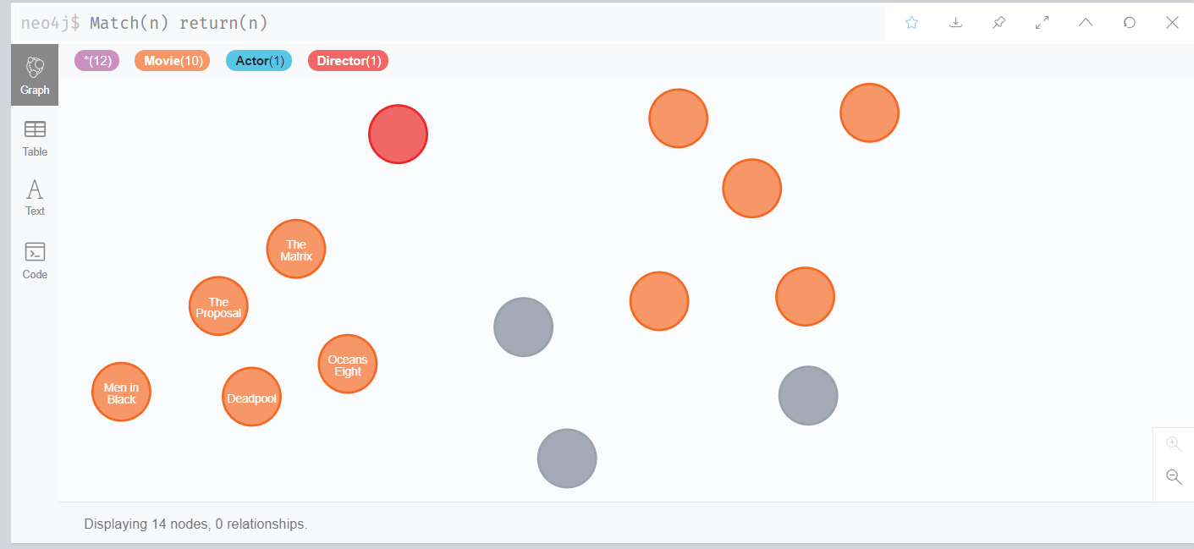

*6. create nodes with parameters as properties*

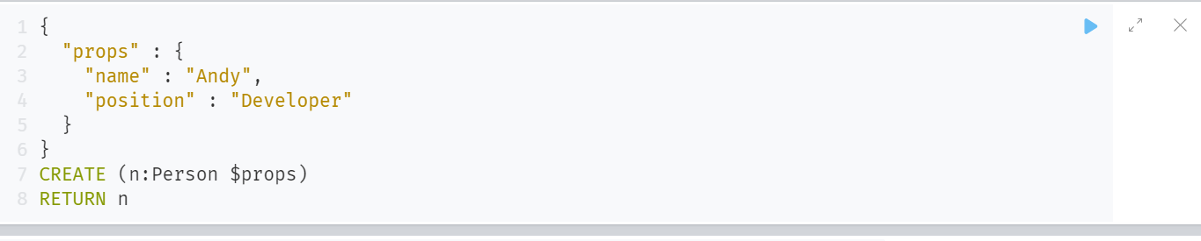

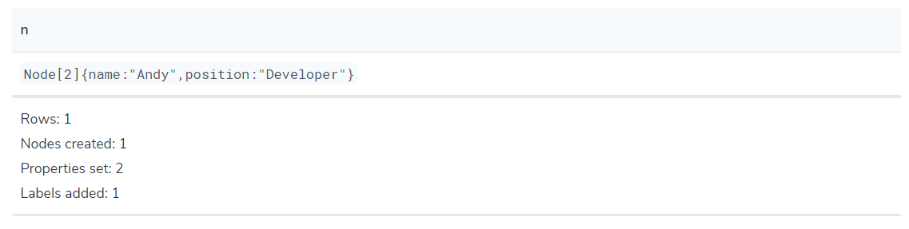

**2. Create Relationships between the nodes**

*7. Create Relationships between the nodes*

Syntax: Match (node1) ,(node2) Where condition Create (node1) [relation type ] ->(node2)

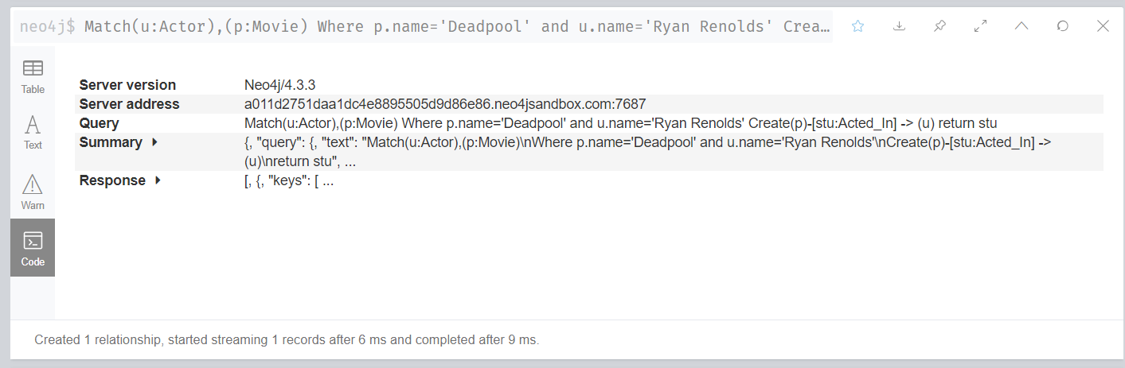

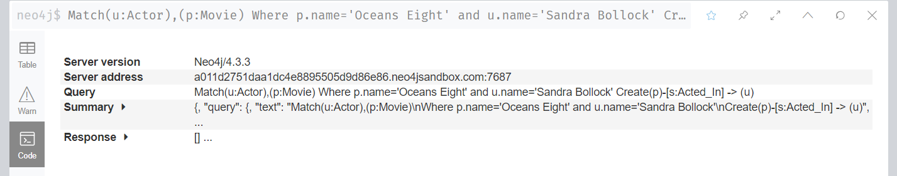

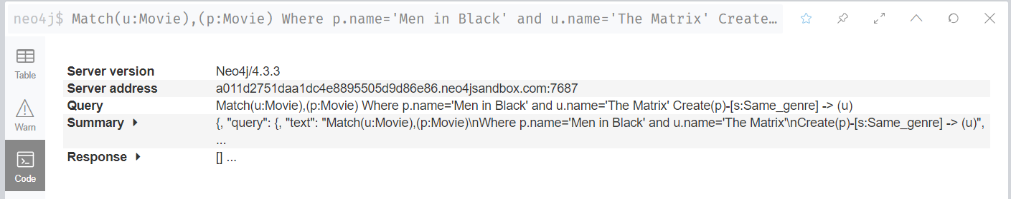

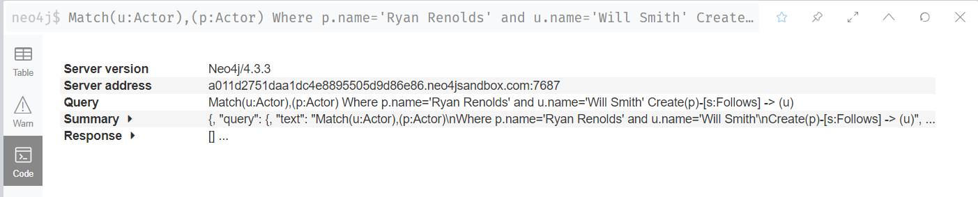

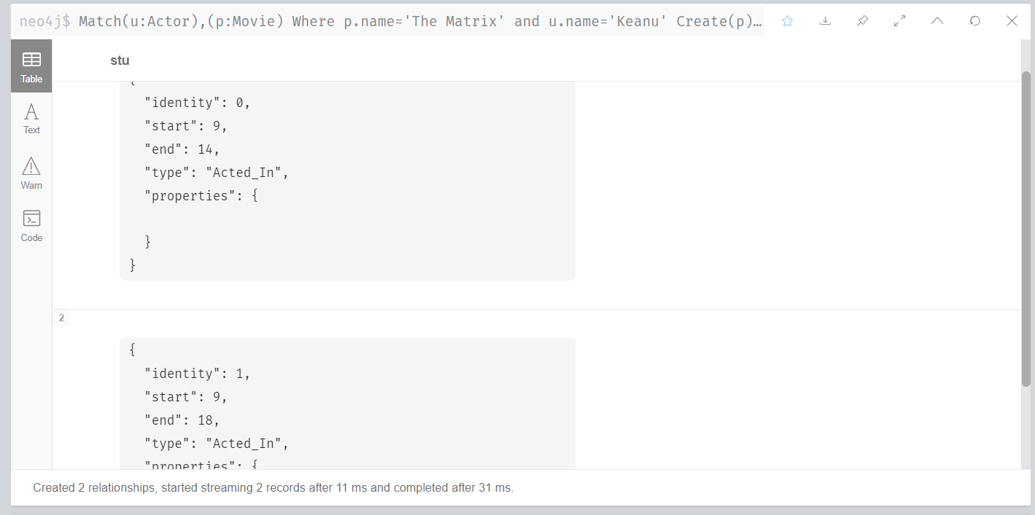

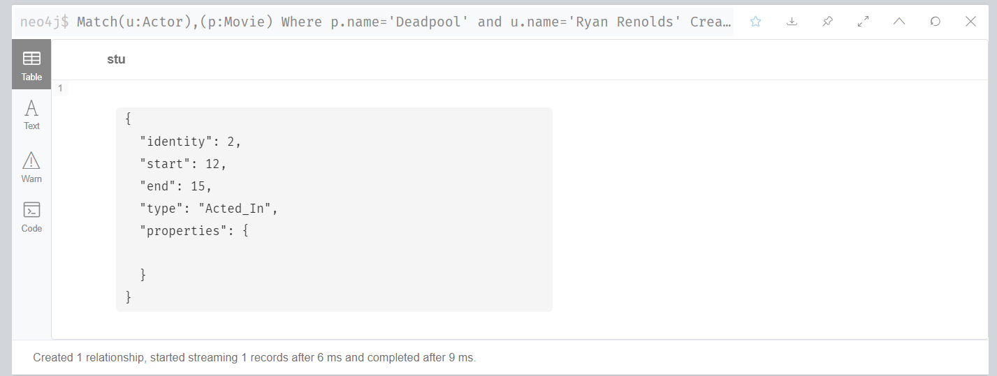

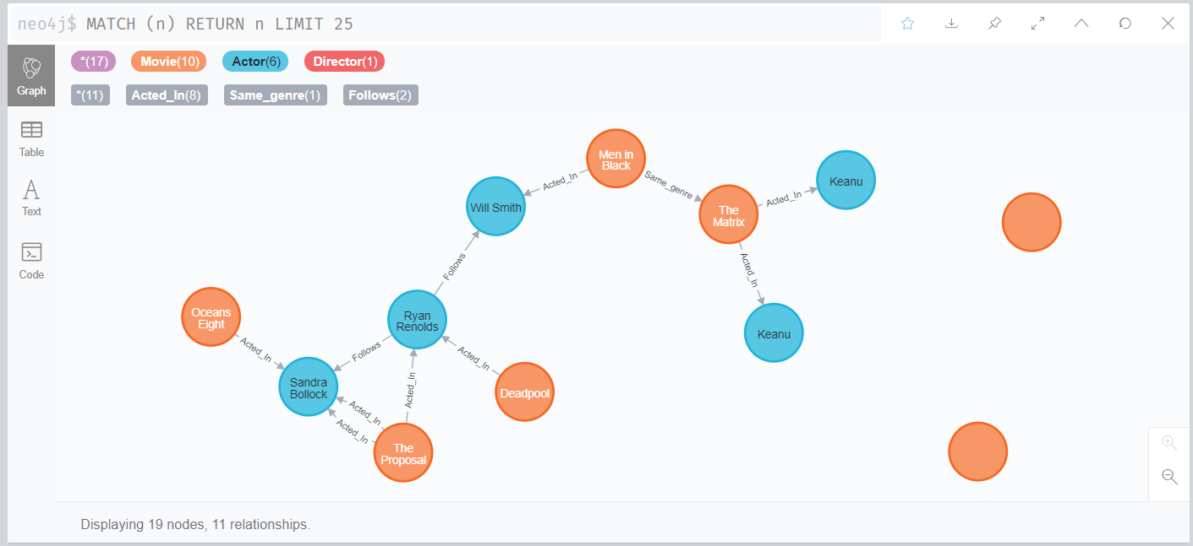

**3. Read nodes and attributes (Node finding)**

8*. Get all nodes*

Syntax: Match(n) return(n)

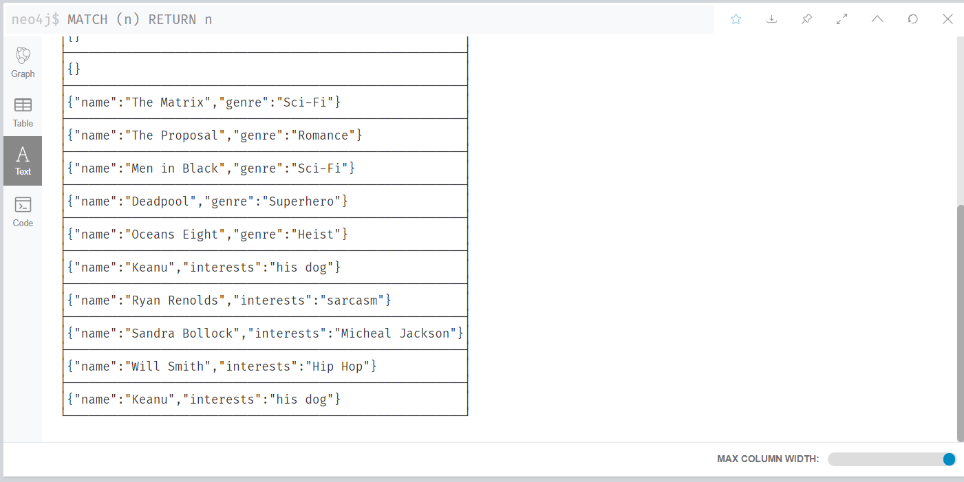

*9. Get all nodes with a label*

Syntax: MATCH (movie:Movie) RETURN movie.title

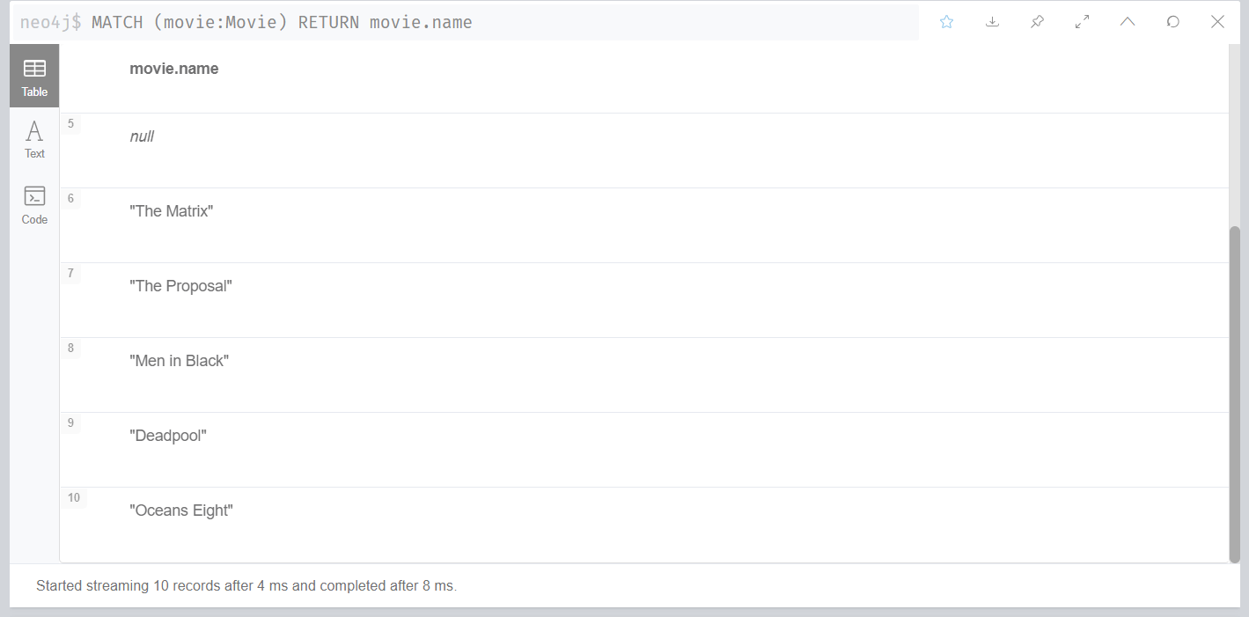

10*. Related nodes*

*Syntax:* MATCH (director {name: 'Oliver Stone'})--(movie) RETURN movie.title

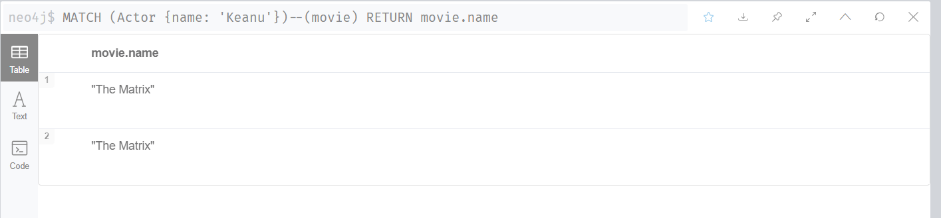

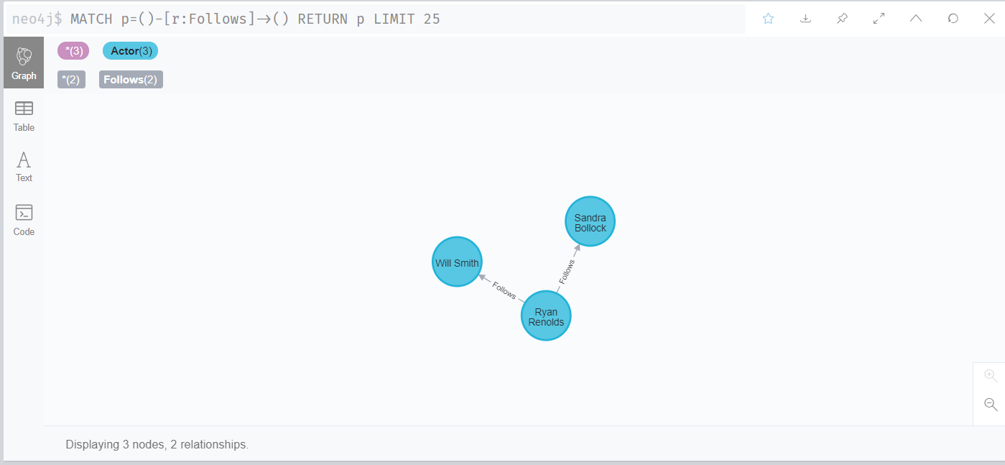

**4. Update or set a value**

11. *Update/set a value*

Syntax: MATCH (n:Node) Set n. propertyvalue = ‘newvalue’

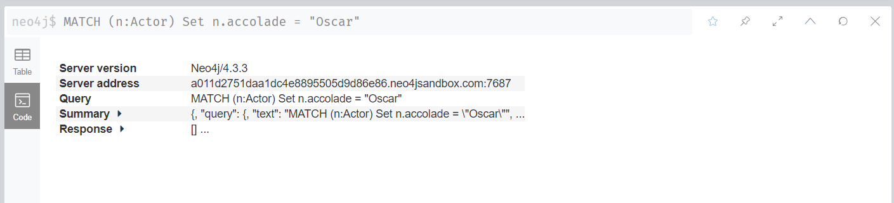

**5. Delete operation**

*12. Delete all node*

Syntax: Delete the relationship Match(n) detach (n)

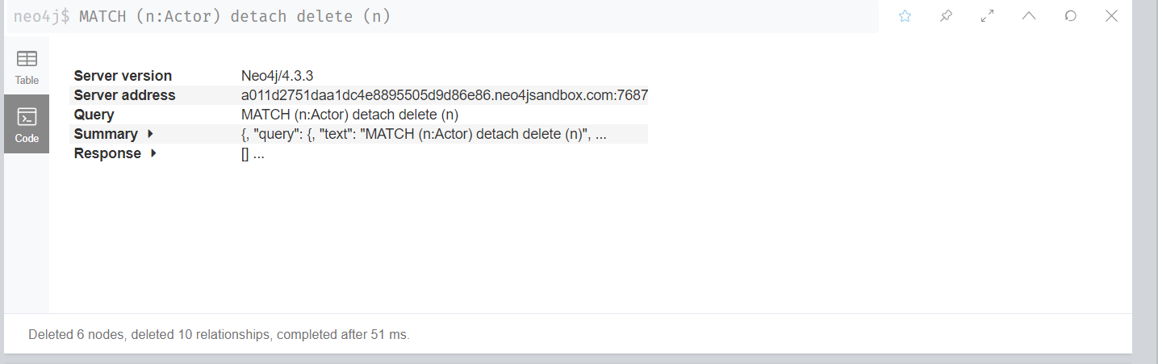

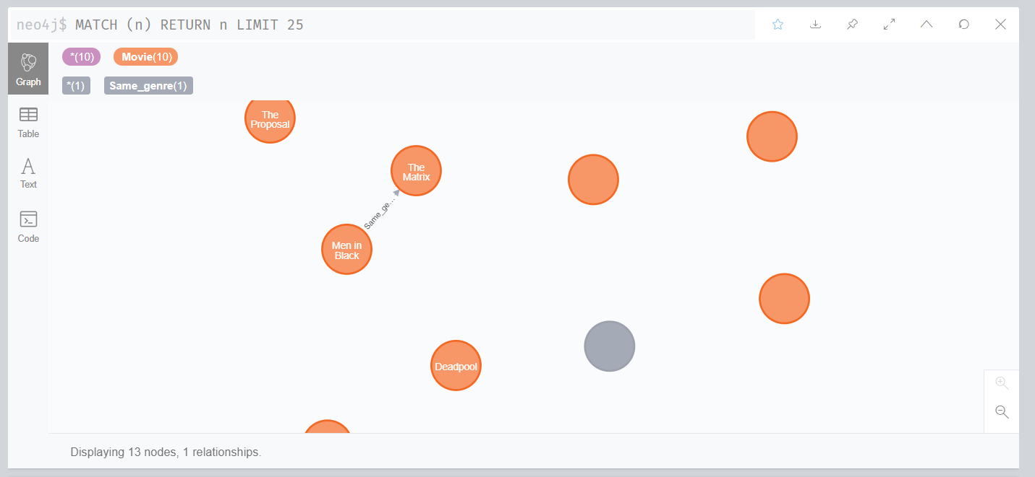

13*. Delete single node*

Syntax: match(filter) delete (n)

